GITHUB ACTIONS

1. What is GitHub Actions?
GitHub Actions is a CI/CD automation tool provided by GitHub.
It automatically performs tasks when something happens in your GitHub repository.
For example:
Developer writes code
↓
git push
↓
GitHub Repository
↓
GitHub Actions
↓
Build
↓
Test
↓
Docker Build
↓
Deploy
So instead of manually doing:
mvn clean package
mvn test
docker build ...
docker push ...
kubectl apply ...
GitHub Actions can do all of it automatically.
#########################
2. Real-time example
Imagine you have a Spring Boot application:
myapp
├── src/
├── pom.xml
├── Dockerfile
└── README.md
Your developer changes the application.
Then:
git add .
git commit -m "Added payment API"
git push origin master
The moment the code reaches GitHub:
GitHub
|
| push event
↓
GitHub Actions
|
┌───────┴───────┐
↓ ↓
Build Test
| |
└───────┬───────┘
↓
Docker Build
↓
Docker Registry
↓
Kubernetes
This is CI/CD.
3. Where do we write GitHub Actions?
Inside your GitHub repository, create:
.github
|
└── workflows
|
└── cicd.yml
So:
myapp/
│
├── src/
├── pom.xml
├── Dockerfile
│
└── .github/
└── workflows/
└── cicd.yml
The .yml file contains the pipeline.
This is similar to Jenkins:
Jenkins → Jenkinsfile

GitHub Actions → .github/workflows/cicd.yml

WHAT IS WORKFLOW?

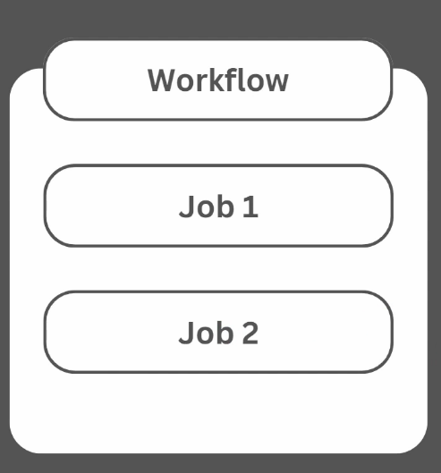

A workflow is an automated process that contains one or more jobs.
workflow is defined in a YAML file inside a GitHub repository.
One repository can have multiple workflows.
A job is a unit of work within a workflow, such as Build, Test, Security Scan, or Deploy.
Each job contains one or more steps.

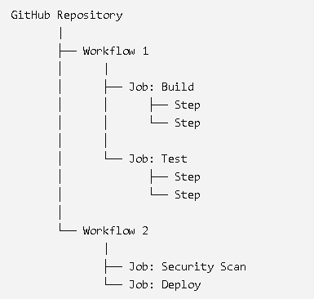

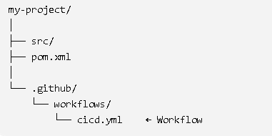
## Under CICD.yml we will create one or more jobs
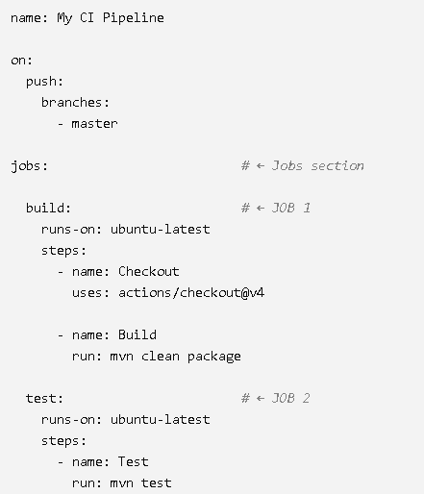

## so visualize it like:
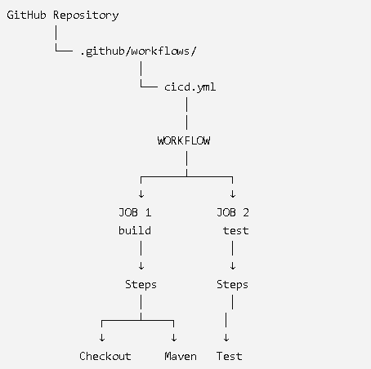

Imagine you are a developer working for Flipkart. You have developed the Order Service. Whenever you make a change to the application and push it to GitHub, we don't want a DevOps engineer to manually build and test the application. We want GitHub to automatically do it.
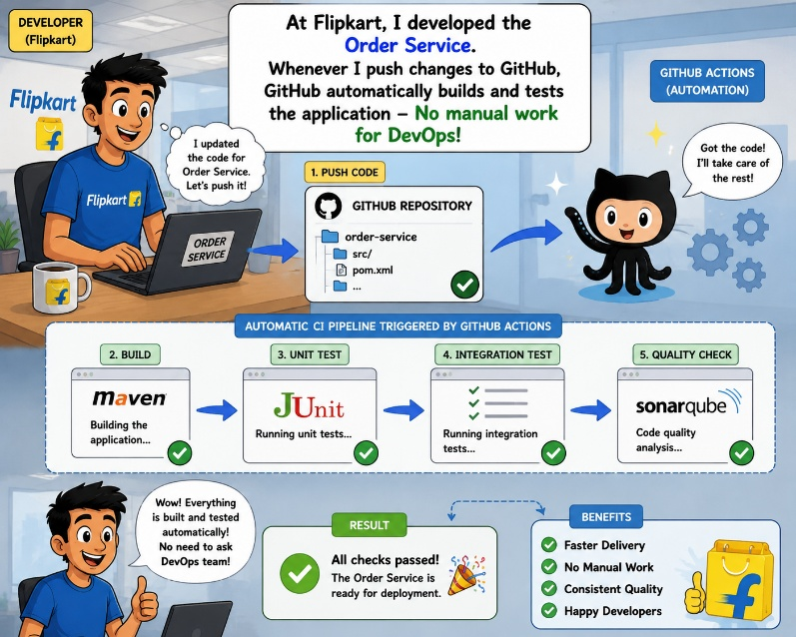

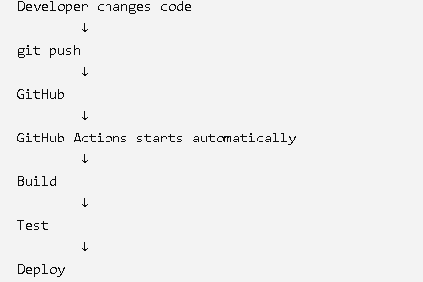

PROJECT:
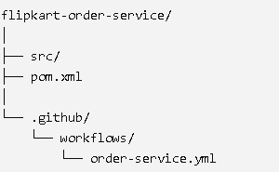
## lets understand the workflow
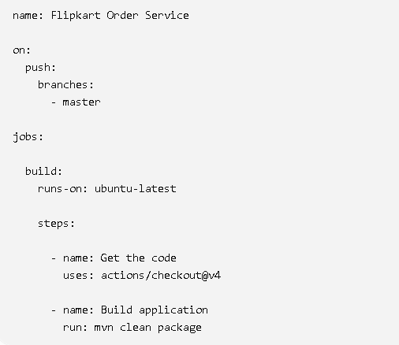
##
name
name: Flipkart Order Service - "This is simply the name of our workflow."
So GitHub will show:
Flipkart Order Service
On
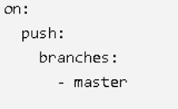
When should our automation start?
Answer:
Whenever a developer pushes code to the master branch.
So:
Developer
|
| git push origin master
↓
GitHub
|
↓
Trigger Workflow
"on tells GitHub WHEN to start the workflow."
jobs
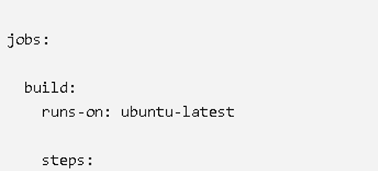
"Now we tell GitHub WHAT work needs to be done."
So:
Workflow
↓
Build Job
Tell them:
"A job is a major unit of work."
runs-on
Now:
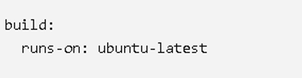
"Where will this build actually execute?"
Answer:
"On an Ubuntu runner."
Runner = machine that executes our job.
Types of Runners
- GitHub-Hosted Runners: These are temporary, clean virtual machines provided by GitHub. They spin up instantly (Ubuntu, Windows, or macOS) and are destroyed after the job finishes.
- Self-Hosted Runners: If you need a specific operating system, high-end hardware, or access to your internal local network, you can install the GitHub Action software on your own server (like an EC2 instance) and register it as a runner.
How to Change the Runner
You control where your job runs using the runs-on keyword.
- For Linux: runs-on: ubuntu-latest
- For Windows: runs-on: windows-latest
- For your own Private Server: runs-on: [self-hosted, linux, production] (You must add the "labels" when you set up the runner on your server).
steps
"Our Build job contains individual steps."
We have:
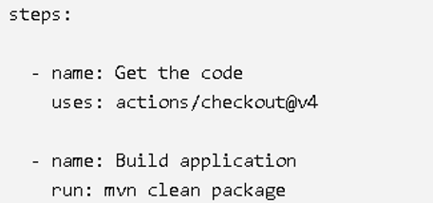
BUILD JOB
|
├── Step 1 → Get code
|
└── Step 2 → Build application
Uses
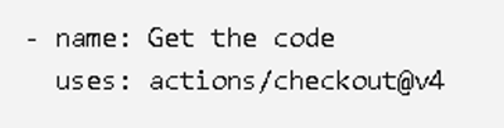
GitHub has already provided an Action called checkout. We are using that Action to get our repository code onto the runner.
Run
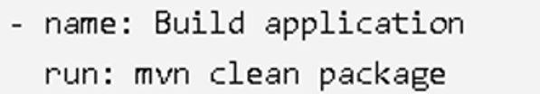

Now the runner executes this Linux command.
uses → use a reusable Action
run → execute a command

####
